LIGHTSCREEN

TOUCHSCREEN SUPPORT FOR ANY COMPUTER MONITOR

IMAAD NISAR

APRIL 2021

TABLE OF CONTENTS

Analysis 3

Reasons for Development 3

An Overview of the Program 5

Features of the Program 7

Design 8

Decomposition of the Problem 8

GUI 8

Testing 9

Deployment 9

Conclusion 9

# Analysis

## Reasons for Development

Given the current climate and the situation with the COVID-19 pandemic, work from home has seen a staggering increase of popularity1. This has included people both in education sectors and in the work sector having to move online. And whilst this has been more favourable to many, it can’t be denied that due to the lack of equipment available at home, it has been difficult for many to work as efficiently as in an environment with any and all the equipment that would possibly be needed.

An example of this is in schools. Given the apparent necessity for face-to-face interaction for effective teaching, it is no wonder that it has been incredibly difficult for students’ learning to not be disturbed. Programs like Zoom, Microsoft Teams and Google Classroom have allowed students to be able to connect with their peers all whilst staying at home. Despite this, there are still a plethora of reasons as to why this cannot be viewed as an alternative to face-to-face teaching given the current technology. A big reason as to why is because students mainly work using pen and paper which is one of the big differences between in person and online teaching. This is a problem that hasn’t been sufficiently addressed and is one of the main reasons for the development of Lightscreen.

Another example is digital art. Currently, the entry requirements for creating digital art are very high with prices reaching the thousands for professional tablets from brands like Wacom. This has meant that creating digital art is not accessible for the average desktop PC user. Lightscreen is not intended to be a replacement for professional drawing devices, rather an affordable entry into the creation of digital art.

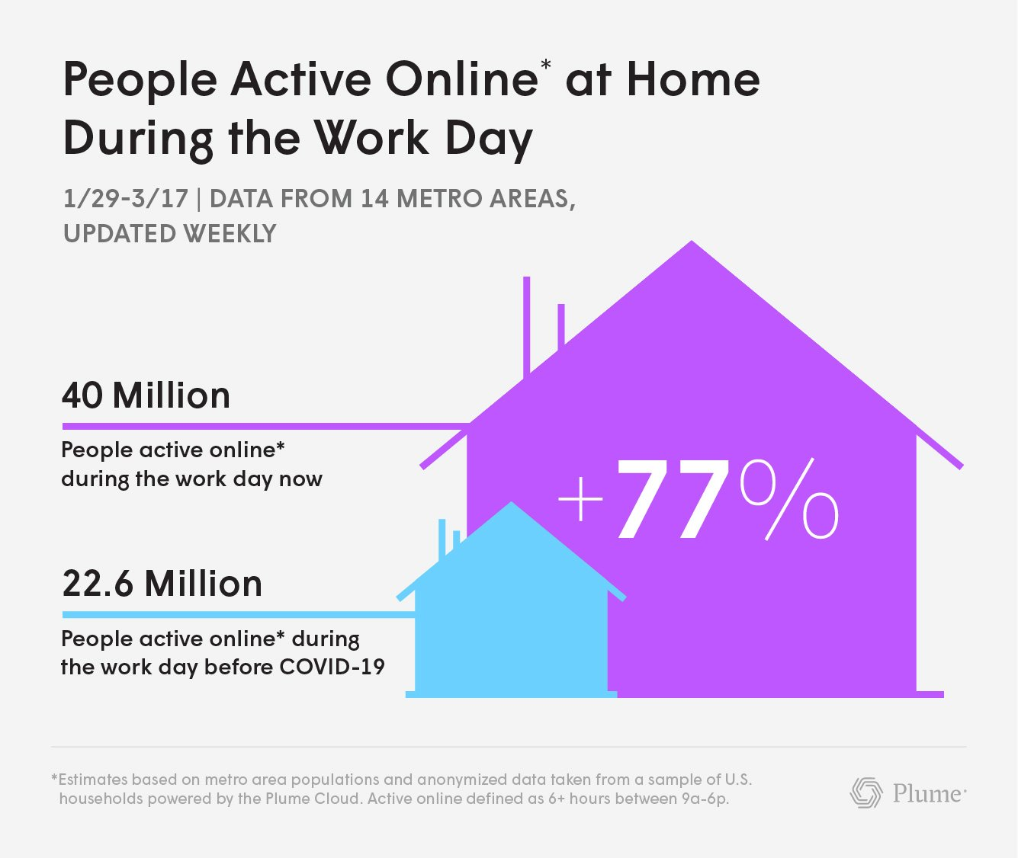

1 Statistics for the increase of people working online. Taken from <https://www.plume.com/> - 09/04/2022

## An Overview of the Program

Lightscreen aims to turn any traditional computer monitor into one that can register touchscreen inputs. It is being developed for Windows 10 and will allow the user to use control their cursor using touchscreen capabilities. The program will be completely free, and the source code will be available on my GitHub: [*https://github.com/ImaadNisar*](https://github.com/ImaadNisar).

The program works with the Lightscreen Stylus which the user will have to have. This can be substituted for a pen laser if the user has one, however, it is intended to be used with the stylus.

Shown left is the circuit diagram for the stylus. Only 3 components are needed to make the stylus making it very affordable and also easy to make. It consists of a 3.0V battery (2 1.5V AAA batteries connected in series) wired to a momentary switch which toggles the blue LED on/off. All the components are fitted into a stylus-shaped cylinder making it comfortable to hold and use as a pen. When making the stylus, I ensure to use insulating tape around the connections to prevent the possibility of a short circuit. A blue LED was used as it has a forward voltage of ~3.0V which means it can be used without the need of a resistor which further reduces unnecessary manufacturing costs. Shown below is a labelled picture of the stylus.

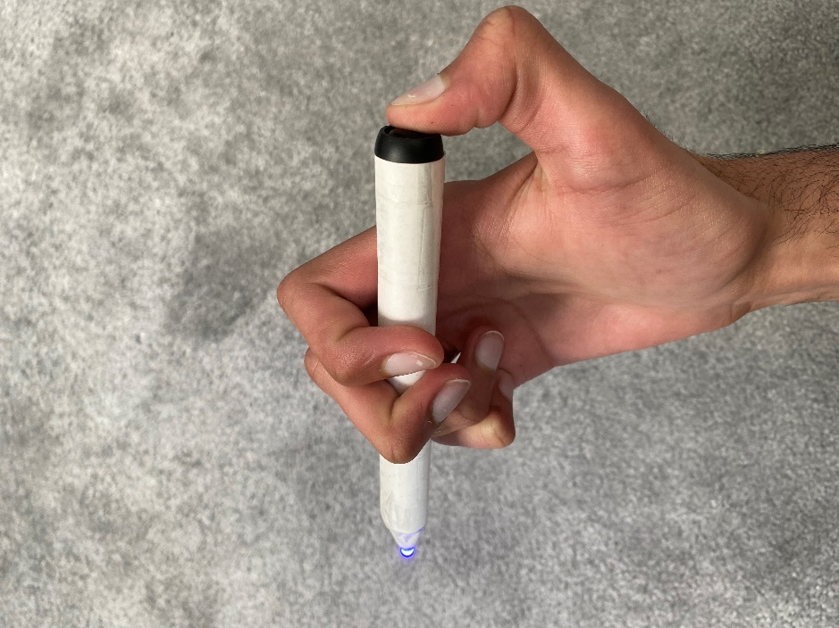

(Inside) 2 1.5V AAA Batteries connected in series

Single 3.0V Blue LED

Momentary Switch

The batteries have a capacity of 450mAh each, so the approximated battery life is around 30 hours of continuous usage.

The program itself will register the stylus using the users webcam which will need to be pointed towards their monitor. The program will require the user to select the corners of the screen which will then be used to create a co-ordinate grid. The program will filter out any of the display’s pixels and track only the stylus’ LED. Depending on the position of the stylus, a co-ordinate will be retrieved which will then be registered as an input. This will be done many times a second to ensure that the user does not experience any ‘lag’ when moving the cursor. The program will be designed to work regardless of things like sunlight or the brightness of the screen.

## Features of the Program

The program will be written in Python with the website being designed using HTML, CSS and JS. The program will be written to be used in Windows 10. The key features that will be included in Version 1.0 are:

* Automatic Start-up – Allows the program to be used at start-up without the user having to open the program or configure the display co-ordinates. This will only work as intended if the location of the camera is unchanged otherwise, the program must be reconfigured.
* Alternative Writing Surface – Allows the user to control their PC without having to touch the screen with the stylus. Instead, the user can use another surface (such as a desk or wall) – this will be ideal if the screen is difficult to reach e.g. a wall mounted monitor or a TV
* User Created Macros – allows the user to create macros which can be used by pressing the button x number of times or holding the button down for x seconds. This allows further customizability of the program and can allow for quick access to certain features e.g. changing pen colour etc.
* Mimics the Mouse – the touchscreen can be used for all the things a mouse can do such as: dragging windows, opening programs, clicking on links etc.

# Design

## Decomposition of the Problem

The project can be decomposed into 3 sub-problems which I will cover individually. These are:

* Interactive GUI and user settings panel written using the tkinter Python Framework
* Image processing and tracking software using the OpenCV Python Framework
* Sleek website with product details, links to source code and customer support page

## GUI

# Testing

# Deployment

# Conclusion